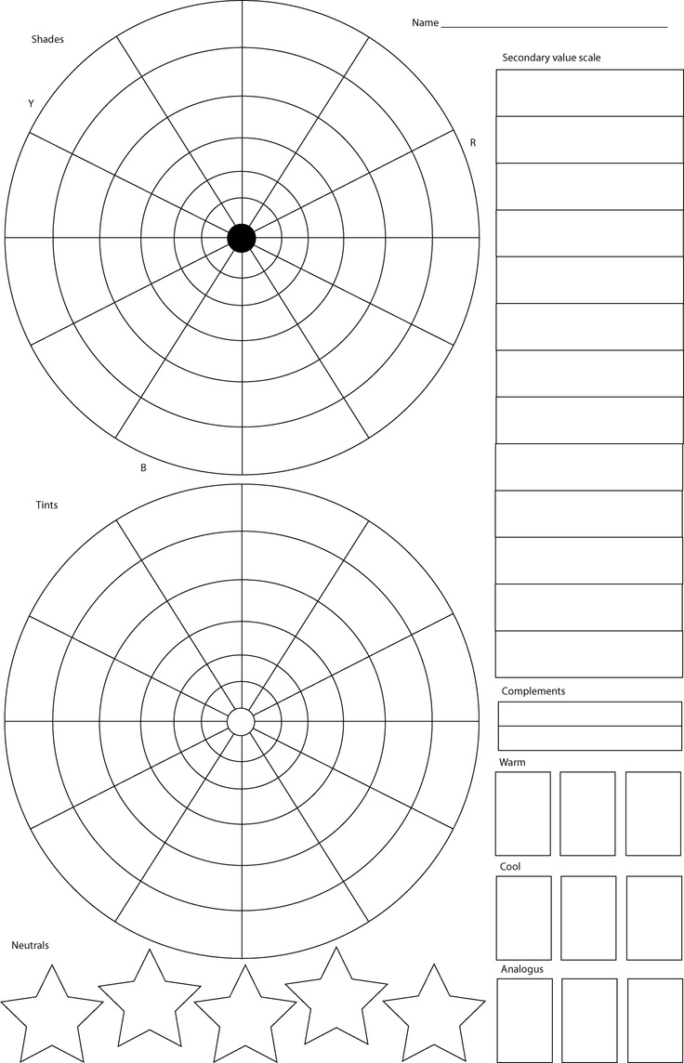

Acrylic Value Scale

Watercolor Value Scale